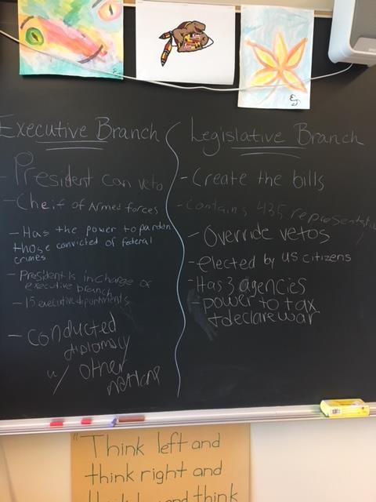

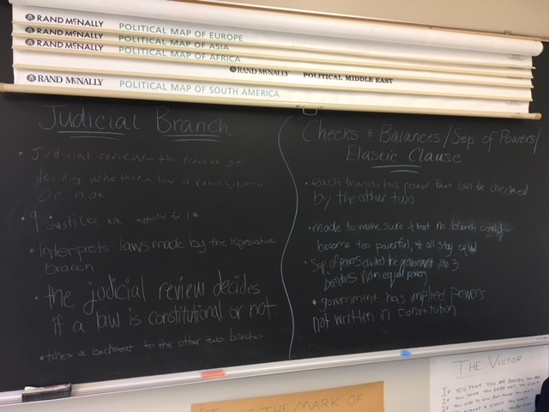

**Decides if laws are constitutional or not**

**9 Justices (Supreme Court Judges) appointed for life**