Name: ________________________________________________ Date: ___________________
Directions: Look at the civil war medical instruments below and try to identify their use.

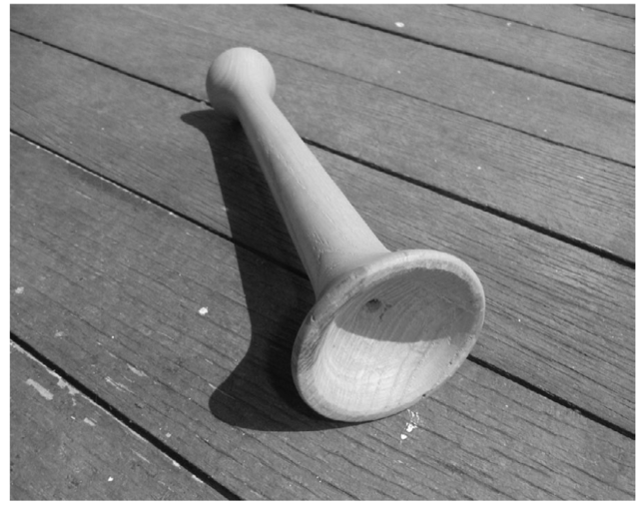
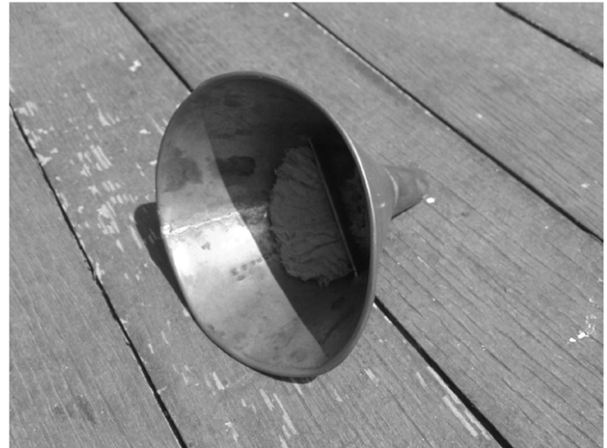

1. ____________________________________ 2. ________________________________
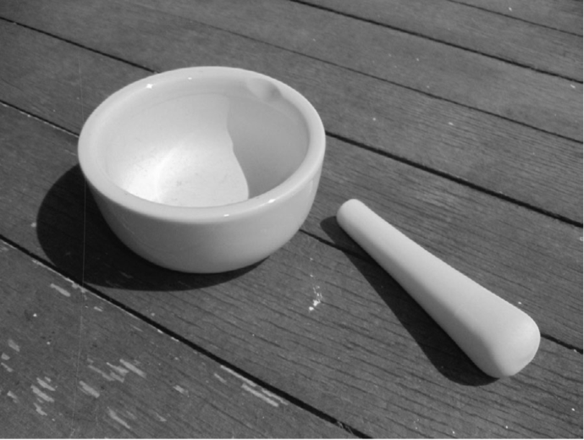
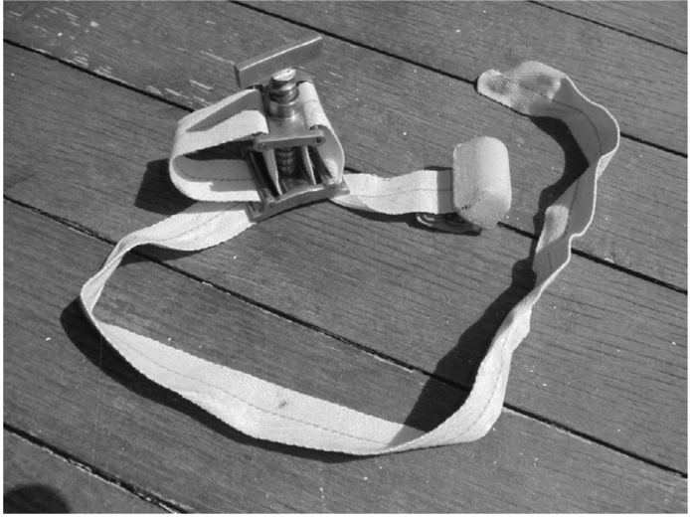
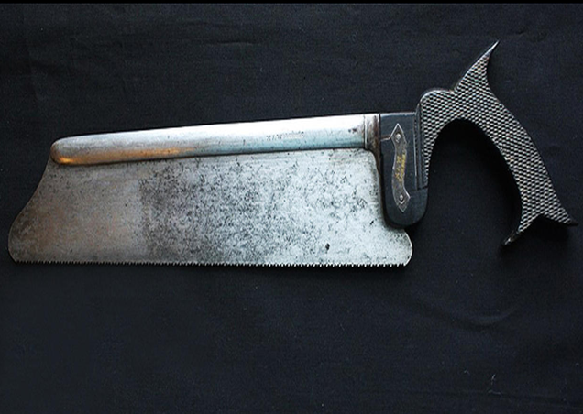
3. ____________________________________ 4. __________________________________
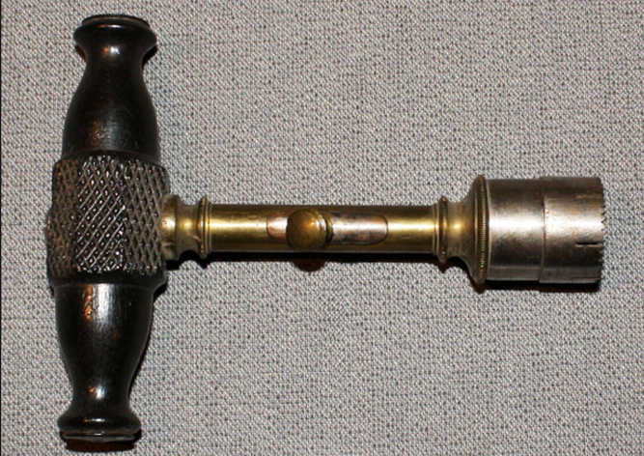
5. ____________________________________ 6. __________________________________
Name: ________________________________________________ Date: ___________________

Diseases | Symptoms
1. Dysentery (Dis-in-TARE-ee):  2. Remittent Fever:  3. Pneumonia:  4. Intermittent Fever:  5. Cholera (CALL-uhr-uh):  6. Diarrhea:  7. Consumption (Tuberculosis):  8. Typhoid (TIE-foyd):  9. Malaria (muh-LAIR-ee-uh):  10. Bronchitis: | 1. Stomach pain, nausea, vomiting and bloody stools  2. Fever fluctuates, but never reaches normal – this type of fever was common with typhoid or malaria  3. Rapid breathing, hot and cold (chills), cough, mucus and chest pain  4. This type of fever follows regular pattern alternating with a return to normal temperature  5. Muscle cramps, diarrhea and vomiting  6. Stomach pain, vomiting, nausea and loose, watery stools  7. Muscle pain, weakness, night sweats, chest pain, cough and general wasting away  8. Headache, dry skin, aching muscles, hot, flushed face, very weak, reddened eyes, sleepy, loose stool and fever  9. Chills, fever, sweating, delirium, nausea and vomiting  10. Fever, chest pain, cough, mucus and trouble breathing

Name: ______________________________________________ Date: _____________________
Directions: Below are actual cases of patients at the Fort Scott hospital during the Civil War. Using the list of common diseases and symptoms above, act as a Civil War doctor to diagnose your patients. Then, use the list of common medications below to treat them.

1. Private James Armstrong of Company D/2nd Kansas Colored Infantry was admitted on October 29, 1863 with cold chills, cough, mucus, and rapid breathing.
a. Diagnosis:
b. Treatment:

2. Private Ira Allen of Company I/3rd Wisconsin Cavalry came to the hospital on October 30, 1863 with nausea, vomiting and bloody stools, and stomach pain.
a. Diagnosis:
b. Treatment:

3. Private Alexander Anderson of Company D/2nd Kansas Cavalry was admitted to the hospital on February 28, 1864 with a fever that would come and go on a regular pattern.
a. Diagnosis:
b. Treatment:

4. Private David Snow was admitted on July 25, 1863 with trouble breathing, cough, mucus, chest pain, and a fever.
a. Diagnosis:
b. Treatment:

5. Private Alexander Atchinson of Company G/6th Kansas Cavalry was admitted on December 23, 1862 after being wounded by a poison arrow.
a. Diagnosis:
Treatment:

6. Sergeant Thomas Sanders of Company G/5th Kansas Cavalry came to the hospital complaining about stomach pain, vomiting, nausea and loose, watery stools.
a. Diagnosis:
b. Treatment:

Common Medications Used During the Civil War Handout
- Alcohol – stimulant or to induce blistering.
- Spirits of ammonia – inhaled as a stimulant.
- Cough mixture – used for coughs, contained glycerine, vinegar, herbs, gum arabic, and whisky.
- Chloroform – used sparingly, would cause vomiting.
- Ether – anesthetic, smelled bad and slow acting.
- Ipecac – stimulated vomiting.
- Lead Acetate – used to treat dysentery.
- Opium and Morphine – relieved pain and relaxed muscles.
- Quinine – used to ease fevers, only effective on malaria.
- Sodium chlorate – used to cool the skin. Taken internally as a diuretic.
- Creosote – helped stop bleeding and destroyed infected tissue.
- Black Tea –stimulant to soothe abdominal discomfort.
- Glycerine – used to soothe skin and was in cough syrup.
Directions: Read the excerpts below from the diary of a Civil War nurse, Amanda Akin. Then, answer the questions that follow.
A. “I meekly followed [the nurse] through the long ward, unable to return the gaze of the occupants of the twenty-six beds, … and with a sinking heart watched her raise the head of a poor fellow in the last stages of typhoid, to give him a soothing draught. Could I ever do that? For once my courage failed.”

B. “It seemed to me this evening, as I sat at my table adding to the list of medicines—writing down name, regiment, list of clothing, etc., of the new arrivals, calmly looking at the poor maimed sufferers carried by, some without limbs, on a ‘stretcher’—that I had forgotten how to feel, … it seemed as if I were entirely separated from the world I had left behind.”

C. “We pass up and down among these rough men without fear of the slightest word of disrespect. They feel their dependence upon us for comfort and entertainment, and the difference in the wards where there is no ‘lady’ shows how much can be done for them.”

1. Make an inference: what do you think caused the highest death toll among Civil War soldiers?

2. Based on Akin’s diary, what was an effect of the Civil War on the nurses?

3. Refer to excerpt C: what role did the Civil War nurses play for the soldiers they were treating?

