Name: _________________________________________________________ Date: _________________
Civil War Battlefield: Virtual Field Trip
What advantages and disadvantages did each side have going into the war?
North
Advantages | Disadvantages

South
Advantages | Disadvantages

Before virtual reality
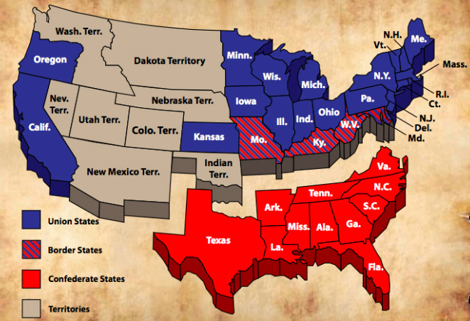

During virtual reality
Fort Sumter
- Where is Fort Sumter?

- Why did the Civil War begin at Fort Sumter?

Gettysburg

During Virtual Reality

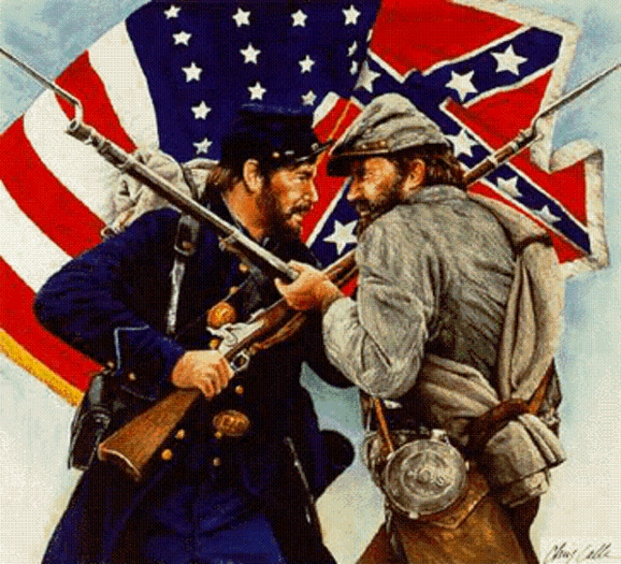

After virtual reality
Imagine you are responsible for creating the soundtrack for a new Civil War movie. What songs would you play during the battle scenes? Choose at least 2 for your playlist.

